**Nombre:**Fanny Gutama **Tema:** Metodo de busqueda A*



**Busqueda Estrella de colegios de Cuenca**

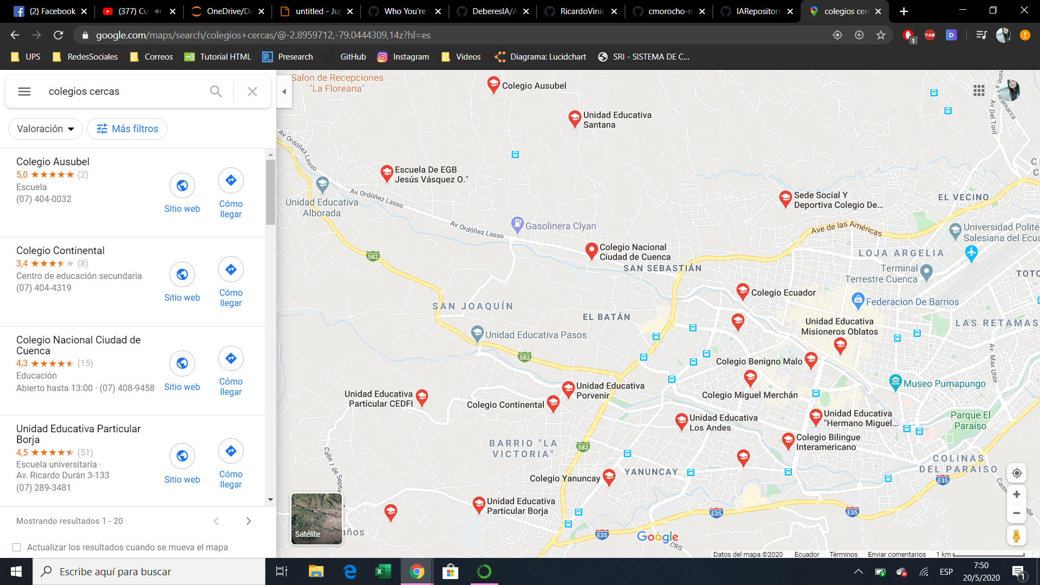

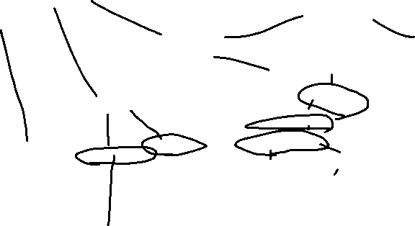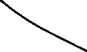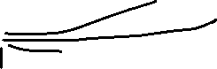

* **Aplicación del metodo A*.**

**Nodo Inicio** = Casa

**Nodo Meta** = Beningno Malo

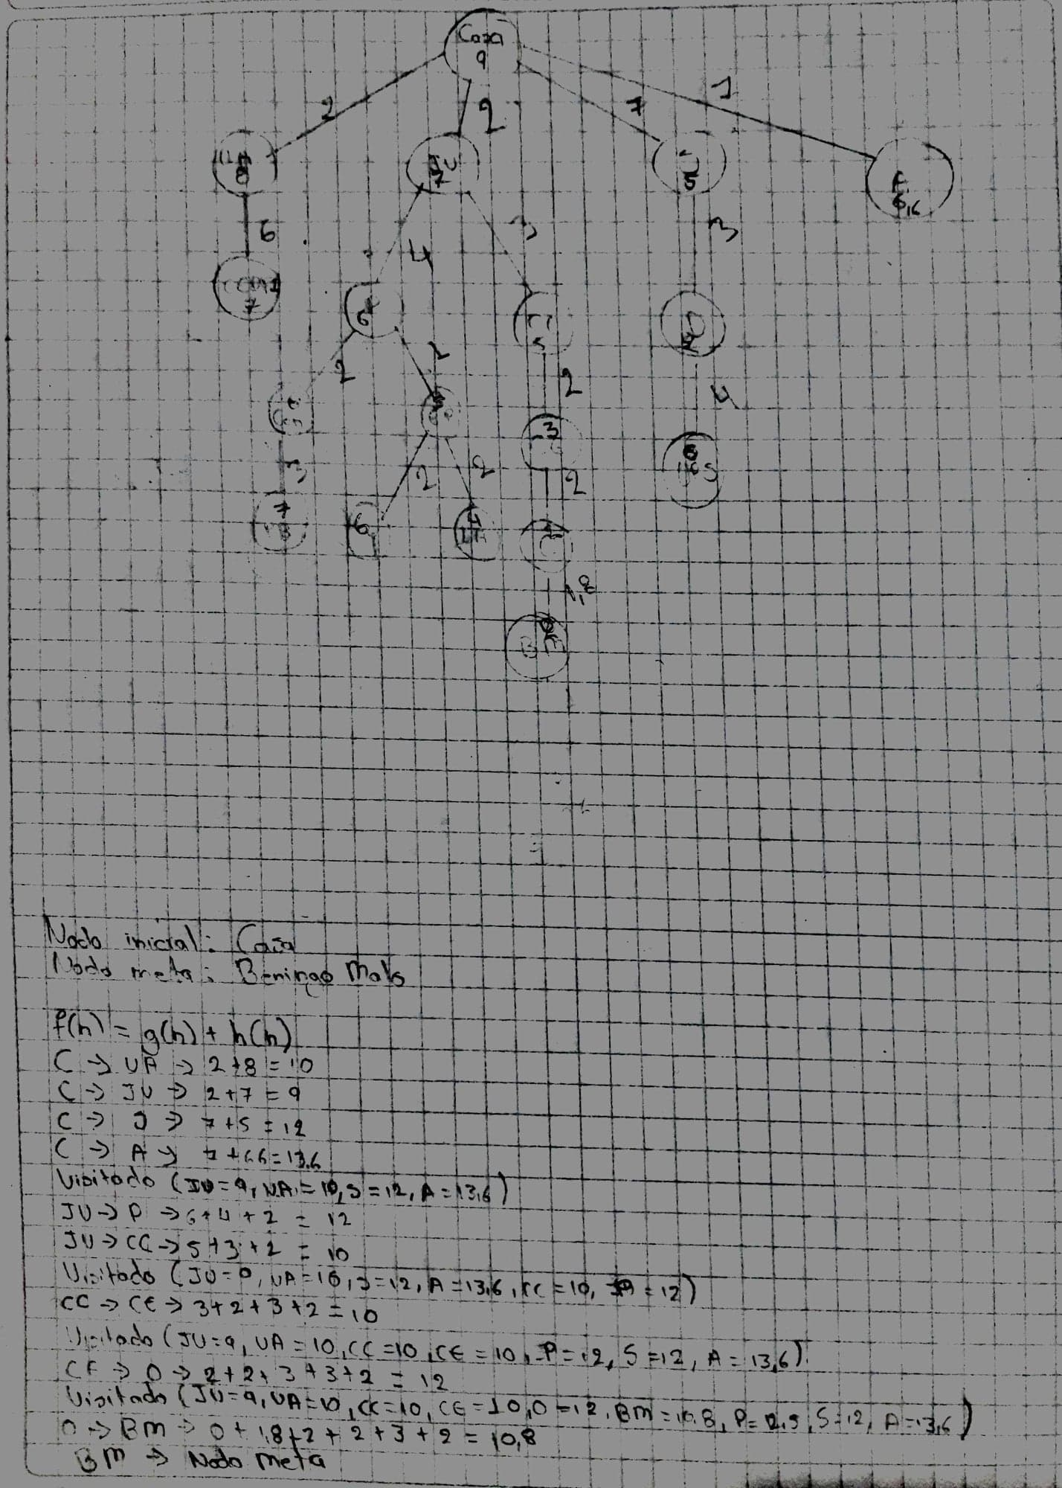

* **Creación de Nodos en NEO4j**

CREATE (c1:colegio {name: 'Casa', latitude: -2.862233, longitude: -79.067879}),

(c2:colegio {name: 'Unidad Educativa Alborada',latitude: -2.862233, longitude: -79.167879}),

(c3:colegio {name: 'Escuela Jesus Vasquez Ochoa',latitude: -2.876566, longitude: -79.061996}),

(c4:colegio {name: 'Unidad Educativa Santa Ana',latitude: -2.872502, longitude: -79.037471}),

(c5:colegio {name: 'Colegio Asubel',latitude: -2.868072, longitude: -79.047755}),

(c6:colegio {name: 'Unidad Educativa CEDFI',latitude: -2.907694, longitude: -79.056893}),

(c7:colegio {name: 'Unidad Educativa Pasos',latitude: -2.899558, longitude:-79.049911}),

(c8:colegio {name: 'Coelgio Ciudad de Cuenca',latitude: -2.889169, longitude: -79.035447}),

(c9:colegio {name: 'Colegio del Deporte', latitude: -2.881736, longitude: -79.011139}),

(c10:colegio {name: 'Colegio Continental',latitude:-2.908443, longitude: -79.040258}),

(c11:colegio {name: 'Unidad Educativa Provenir',latitude: -2.906760, longitude: -79.038340}),

(c12:colegio {name: 'Colegio Ecuador',latitude: -2.893559, longitude: -79.016539}),

(c13:colegio {name: 'UPS',latitude: -2.885853, longitude: -78.989428}),

(c14:colegio {name: 'Unidad Educativa Particular Borja',latitude: -2.921317, longitude: -79.049718}),

(c15:colegio {name: 'Colegio Yanuncay',latitude: -2.917722, longitude: -79.033162}),

(c16:colegio {name: 'Unidad Educativa los Andes',latitude: -2.910777, longitude: -79.0239092}),

(c17:colegio {name: 'Unidad Educativa Oblatos',latitude: -2.901196, longitude: -79.003907}),

(c18:colegio {name: 'Benigno Malo',latitude: -2.903000, longitude: -79.007562}),

(c1)-[:CONNECTION {distancia: 2}]->(c2),

(c1)-[:CONNECTION {distancia: 2}]->(c3),

(c1)-[:CONNECTION {distancia: 7}]->(c4),

(c1)-[:CONNECTION {distancia: 7}]->(c5),

(c2)-[:CONNECTION {distancia: 6}]->(c6),

(c3)-[:CONNECTION {distancia: 4}]->(c7),

(c3)-[:CONNECTION {distancia: 3}]->(c8),

(c4)-[:CONNECTION {distancia: 3}]->(c9),

(c7)-[:CONNECTION {distancia: 2}]->(c10),

(c7)-[:CONNECTION {distancia: 1}]->(c11),

(c8)-[:CONNECTION {distancia: 2}]->(c12),

(c9)-[:CONNECTION {distancia: 4}]->(c12),

(c10)-[:CONNECTION {distancia: 3}]->(c14),

(c11)-[:CONNECTION {distancia: 2}]->(c15),

(c11)-[:CONNECTION {distancia: 2}]->(c16),

(c12)-[:CONNECTION {distancia: 2}]->(c17),

(c17)-[:CONNECTION {distancia: 1.8}]->(c18)

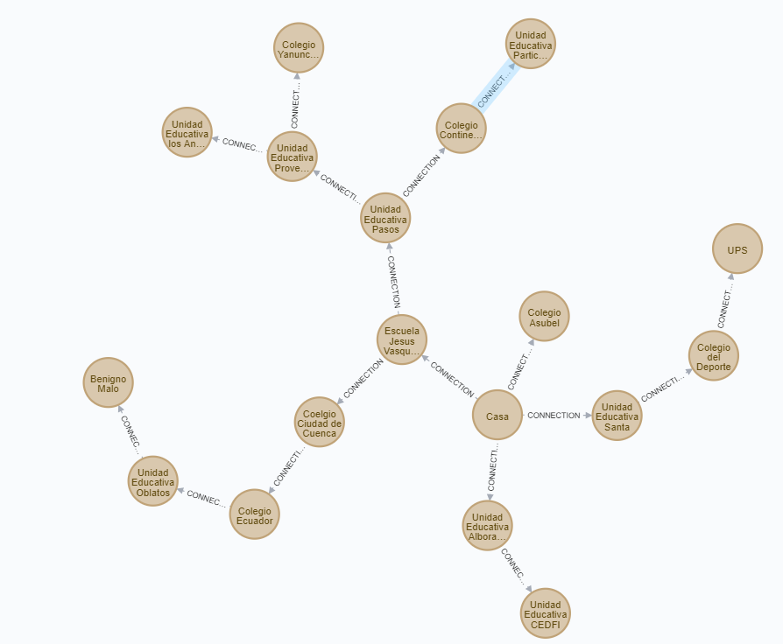

* **Aplicación del método en NEO4J**

MATCH (start:colegio {name: "Casa"}), (end:colegio {name: "Benigno Malo"})

CALL gds.alpha.shortestPath.astar.stream({

nodeQuery: 'MATCH (c:colegio) RETURN id(c) AS id',

relationshipQuery: 'MATCH (c1:colegio)-[r:CONNECTION]->(c2:colegio) RETURN id(c1) AS source, id(c2) AS target, r.distancia AS distancia',

startNode: start,

endNode: end,

relationshipWeightProperty: 'distancia',

propertyKeyLat: 'latitude',

propertyKeyLat: 'longitude'

})

YIELD nodeId, cost

RETURN gds.util.asNode(nodeId).name AS station, cost

